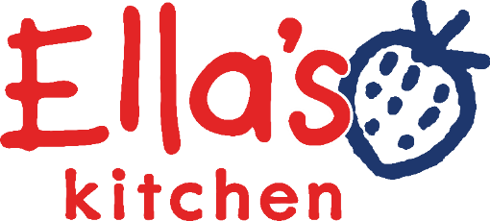

Food Technologist
Making Things Right/Technical + R&D Team

Ella’s Background

Ella’s Kitchen was set up by Paul Lindley to promote healthy eating amongst babies and young children. We’re a highly entrepreneurial and values driven company which has achieved impressive growth to over £80m turnover, with a team of 80 employees based at Ella’s Barn near Henley. Our baby and toddler food pouches can be found in key retailers across the UK as well as the Scandinavian and BeNeLux markets. We are a brand recognised for its high-quality ingredients and ethical credentials which are visible throughout our supply chain and in our social and charity work. Ella’s is part of the Hain Celestial group and we are very proud to be an accredited B’Corps.

Ella’s is an established business embarking on an exciting new phase of development, to bring out more ranges of products and reach an even wider audience. With an ambitious growth target, we are looking for an enthusiastic, passionate and talented individual to take on the role of a Technologist to assist our Technical team.

You will be joining a team of people who meet personal and business challenges with hard work and a smile. They not only see things as they are and ask why - but see things that never were and ask why not.

At Ella’s Kitchen, we are guided by our values; they set the tone of our culture and we look out for newbies who will be a natural fit to our values and complement and contribute to our business.

Location: Near Henley in Thames

Please note, we are an office and not a factory and therefore do not produce anything on our site in Henley, however there may be the option to visit some of our manufacturing partners across the UK and Europe.

Reports to: Senior Technical Manager

Direct Reports: None

Contract: Full time, 40 hours (Monday to Friday) Usual work pattern requires min 2 days per week at our office location outside of Henley on Thames. Please note there are no public transport links and you will need access to a car.

Role activities / responsibilities:

1. Customer complaints
- Support customer care and technical managers with customer complaint investigations
- Analysis of customer complaint data (including weekly and monthly reporting and trending as required)
- Updating co-manufacturer and company scorecards with complaint data
- Run internal complaint meetings with the wider team. Monthly meetings also include details on non conformances, change controls and artwork changes.
- Collate co-man quarterly complaint charges

2. Artwork
- Collation of technical and marketing information required for generation of artwork
- Manage artwork process and timings (UK and International) – with internal team, repro house and printers.
- Liaise with Trading Standards/ organic certifier/ co-mans/ distributors for artwork approval

3. Export
- Completion of all documentation for exporting (e.g. organic, health certificates, CofA’s etc)
- Support investigation into export requirements of new countries

4. Documentation, Systems and Specifications
- Main point of contact for all distributor and customer technical queries
- Specification completion and managing specification requests (raw material, finished product and retailer specifications)
- Maintain up to date certifications on file
- Support with annual organic audit

You will need:
- Undertaking a degree in Food Science/Nutrition/Technology/food marketing or a related discipline with an industrial placement year as part of your degree course
- A strong desire to get hands-on experience and learn about working within a food brand
- Brilliant knowledge and capability with using MS Excel, PowerPoint and Word
- Strong attention to detail and organisational skills
- Self-motivated with a proactive approach to work
- Demonstrable ability to live and breathe our values: Own it, Foster Inclusion, Be Curious, Win Together, Childlike
- Our office based in the beautiful countryside just outside of Henley on Thames. There are no public transport routes, so having access to a car is essential.

And what you’ll get in return:
- Bucket loads of training and development, supporting your career pathway
- An Ella’s Buddy – a friendly face to support you throughout your placement and help with any questions you may have
- 25 days holiday
- A really awesome place to come to work every day… our beautiful Barns in the Oxfordshire countryside

