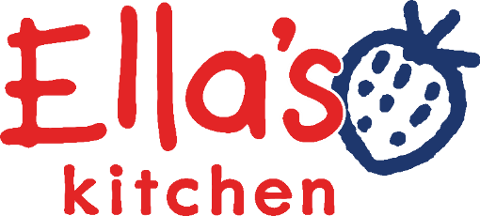

Assistant Brand Manager
(Friends Team)

Ella’s Background

Ella’s Kitchen was set up by Paul Lindley to promote healthy eating amongst babies and young children. We’re a highly entrepreneurial and values driven company which has achieved impressive growth to over £80m turnover, with a team of just under 80 employees based at Ella’s Barn near Henley. Our baby and toddler food pouches can be found in key retailers across the UK as well as the Scandinavian and BeNeLux markets. We are a brand recognised for its high-quality ingredients and ethical credentials which are visible throughout our supply chain and in our social and charity work. Ella’s is part of the Hain Celestial group and we are very proud to be an accredited BCorps and included in the Sunday Times Best Companies top 100 list for the last 5 years.

At Ella’s Kitchen, we are guided by our values; they set the tone of our culture and we look out for newbies who will be a natural fit to our values and complement and contribute to our business.

Location: Henley on Thames

Reports to: Senior Portfolio Manager

Contract: Full time Permanent

Purpose of Role: Support portfolio managers with best-in-class range management. Ensuring that our products continue to meet the needs of parents & carers in our UK & ATW markets.

Role activities / responsibilities:

EPD + NPD project Delivery:
Support on EPD + NPD projects for the UK + Around the World as required by:
- Manage end-to-end artwork execution and repro after concept sign-off, ensuring packaging is compelling, accurate, and compliant across all projects.
- Ensure your packaging projects come in on time + on budget.
- Support portfolio managers in continuously scanning for inspiration, trends, and opportunities to drive future innovation
- Support portfolio manager on projects from ideation through to launch, championing them through the internal development process
- Championing our consumers by keeping them front of mind – be Kids First always!

Ready to sell delivery:
Setting our innovation up for success by:
- Working with key partners + internal teams to ensure 3D + optimised images are within brand guidelines and readily available for retailers + distributors. Ensure product information is correct on retail channels.
- Championing the voice of the consumer throughout the Barns, organising inspiring launch parties and tastings for colleagues in the barns.
- Support the portfolio managers and deals (sales) team in Retailer sell-in sessions

Communications
- Provide ad-hoc support to the Communications team, including copywriting, creative execution and assistance across campaigns and digital channels.

Other Stuff
- Be an active member of the wider Friends team by collaborating and contributing your passion and ideas.
- Support the wider friends team activities as required (e.g. monthly team meetings).

You will need:

- To embrace, embody and exude all that is special and unique about Ella’s Kitchen
- Demonstrable evidence of experience + passion to build a career in Marketing
- Ability to excite and energise the people around you
- Great organisational skills and attention to detail. Ability to juggle multiple tasks at once.
- Bags of creativity!
- A real passionate team player with the ability to work cross-functionally
- Demonstrable ability to live and breathe our values: Win Together, Own It, Be Curious, Foster Inclusion, We’re Childlike
- Passion for the brand and what Ella’s stands for – improving children’s lives through developing healthy relationships with food.

And what you’ll get in return:

- Bucket loads of training and development, supporting your career pathway
- Competitive salary
- Discretionary bonus scheme
- A Box of Treats, our fantastic benefits package
- A really awesome place to work whether over Teams or in our beautiful Barns in Oxfordshire!

